**Optional Tasks/Projects:**

**1-** explore any of the following famous landmarks of South America by doing some research online.

**Machu Picchu**, Peru/ **Amazon River**, Brazil and Peru/ **Iguazu Falls**, Brazil & Argentina/ **Christ the Redeemer**, Brazil/ **Perito Moreno Glacier**, Argentina/ **Salar de Uyuni**, Bolivia/ **Angel Falls**, Venezuela

Make some notes and split them up into suitable headings. Use your information to create an information leaflet about the for people who are interested in visiting and want to find out more.

Think about:

* How you are going to link your information together. Don’t just give a list of facts.
* How are you going to persuade someone that they would like to go?
* What are the best things to do while you are there?

**2**- take a virtual field trip, using the following link- <https://freedomhomeschooling.com/virtual-field-trips/> The site allows you to visit places around the world without ever leaving your homes. You can visit the states of North America, other countries across the globe, and even planets.

**3**- use **Pobble 365** to select a daily writing task based on the changing image stimulus e.g.

**4**- find Science experiment ideas to complete in the home (with your adults’ permission). <https://www.rigb.org/families/experimental>, Year 6 topics include; light, electricity, animals including humans, evolution and living things and their habitats

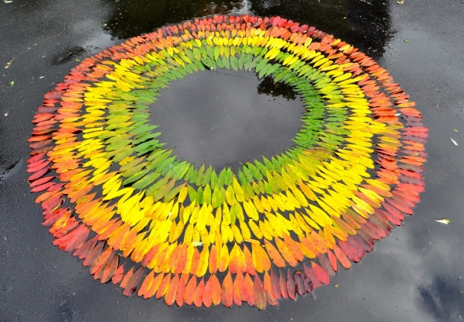**5**- create your own Andy Goldsworthy inspired land art outside. You could explore his work further and make a portfolio about him and his art.

<http://www.artnet.com/artists/andy-goldsworthy/>

**6**- select a language to either practise or learn as a beginner. Duolingo is free but allows you to create a login if you’d like to track your new learning and language progress.

[https://www.duolingo.com](https://www.duolingo.com  )

**7**- develop your science, technology, engineering and maths skills through the STEM starter activities e.g.-

Check the link weekly for suggested activities <https://www.stem.org.uk/resources/elibrary/resource/468235/starters-stem>

**8-** research your Family Tree.Ask questions to the adults in your household regarding your relatives and ancestors, you could even ring them and involve them in the project.You might also discover your family crest or choose to design your own.

**Additional Tasks**- browse the PDF booklets that cover a range of subjects and skills that you may wish to complete. There’s also some quiz questions for you to play against your adults.